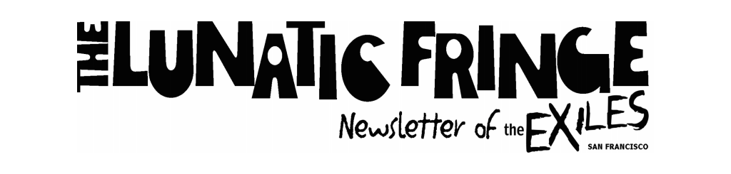

**August Program:**

**BDSM Women’s Herstory Panel**

**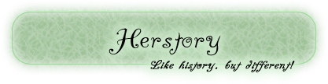**

Friday, August 15, 2014 •

**Center for Sex & Culture**

**1349 Mission St (between 9th & 10th)**

**San Francisco**

**Doors open: 7:30 pm, Program: 8-10 pm**

**$4 for members, $10 for non-members**

*Cardea, Samois, Outcasts* ~ Did you know these were the names of the first leather groups for women, by women, in SF? We are fortunate enough to have leather groups surrounding us now in the Bay Area, but what was it like when there were so few? Come to our August program and get to know your leather herstory and the women who were part of it, on August 15 at The Center for Sex and Culture. Gayle Rubin, Sybil Holiday and Amber Rae will share their stories firsthand.   
  
About our presenters…  
  
**Gayle Rubin** has been involved in the local women’s SM scene since 1978. She was among the founders of Samois and the Outcasts, and is a member of the Exiles. She does research on the history of kinky communities. *Deviations*, a collection of her essays, is available from Duke University Press.  
  
**Sybil Holiday** has been privately involved in San Francisco’s SM scene since 1980, and as a professional dominant, “M. Cybelle,” from 1983 to 2005. A member of The Society of Janus, The Outcasts, and The Exiles, she is also co-author, with William A. Henkin, PhD, of “*Consensual SadoMasochism; How to Talk About It & How to Do it Safely*.” In 1983 for a Society of Janus program that she and Mistress Cassandra presented she coined the term “Ageplay” because for her, language is a fetish.  
  
**Amber Rae** has been involved in SF SM since 1975 and was the founder, along with Kaye Buckley and Jay Magus, of Cardea, at the behest of Janus Society. She’s been a member of Samois and the Outcasts and just doesn’t have the energy any more to take advantage of the Exiles (except once in a long while).

Please come and welcome these foremothers of the Exiles, get to know them and taste a piece of our Herstory!

Program Meeting Information:

* All women (and those whose gender self-identification is other than male) over 18 are welcome.
* Members $4; non-members $10. Please have membership card or ID ready to speed entry.
* ASL interpretation is available on request. Please contact Lou at mzconductor@gmail.com at least three days in advance if you need an ASL interpreter, and one will be provided.
* Visit our website for more information.

**You Will be missed, Suzanne!**

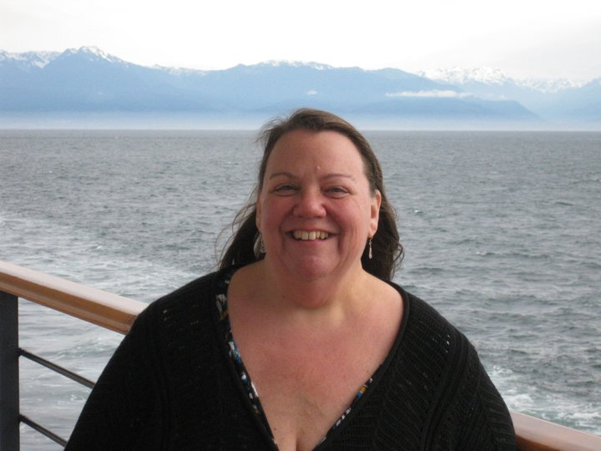Suzanne Corson, a longtime Exiles member and a former officer, passed away suddenly on July 31st of a heart attack. We are all heartbroken. She was a bright spirit, with a ready smile and a warm heart. A longtime bookseller, she ran Bodecia's Books in Kensington for several years. Most recently, she edited The Fringe for us, before moving to Nevada with her partner Wendy a few months ago.

Wendy put together this brief collection of video snippets on Facebook:  [https://m.facebook.com/story.php?story\_fbid=939475489399807&id=100000120943322](https://m.facebook.com/story.php?story_fbid=939475489399807&id=100000120943322" \t "_blank)

Her friend Simone Campbell has organized a candlelight vigil and memorial lake walk tomorrow, Monday August 11th, 8pm, at Lake Merritt in Oakland, saying "The Bay Area queer community has lost a true angel. Join me in honoring her memory. Bring candles, drums, instruments, and your stories. We'll be walking the lake, starting at the pillars, and ending at the Lake Chalet. We do this for her family and partner who cannot be in attendance, and for all who loved her. Whether it's from her amazing bookstore, Bodecia's, or Mills College, or if you knew her as a writer for AfterEllen.com. spread the word far and wide.”

We'll miss her deeply.

**Novice Night – July’s Program Review** 

July’s program offered an opportunity for novices of our kink community listen to a panel about their experience about coming out as Kinky, BDSM, D/S, and joining the community. On the panel were Patti (IMsL 2014), Lady Raven, Janel (a novice), Bennett, Jak and Rio. They told their unique stories and answered questions from the attendees. After we finished our Q & A, there were various stations of sensation, for our guests to interact with different toys and play activities. Rio had pervertable sensation toys such as clothespins, a bunny flogger, a plastic knife, and more. Lady Raven showed her hand at whips, floggers and canes. Jak generously gave time at the spanking bench with different paddles and toys. Everyone ended up having a great time. Patti was a surprise guest, who was able to join us because her flight to Portland was canceled. All in all, it was a great ice breaker for the novices, and a fun time for all.

****

**It’s Membership Renewal Time**

**All Exiles memberships expired at the end June**, so it’s now a bit past time to renew your membership for 2014-2015. But it’s **NOT TOO LATE!!!** It’s easy to do, all online:

1. Click on the [Renewals Page](http://theexiles.org/membership/renewal/" \t "_blank) on our web site.
2. Click on “Fill out the online form” \*
3. Fill out the form and click Next.

If you don’t know your member number, just leave it blank.

* + All members in your household can renew at once here.
  + **Check out the new “Supporting Member” addition**

1. Select your renewal type from the drop list and click Pay Now, which takes you to PayPal to pay. \*\*
2. Pay as directed.

**As a reminder, as an Exiles member you get the following benefits:**

* Reduced entrance fee for Exiles programs ($4 versus $10).
* Reduced cost on safer sex supplies sold at programs.
* The Exiles newsletter, *The Lunatic Fringe*.
* The right to attend and vote at business meetings, and to run for an office.
* Reciprocity with some other BDSM clubs (Society of Janus, Lesbian Sex Mafia (New York), Black Rose (DC area), Bound By Desire (Austin), and our most recent addition, the Bad Girls of Portland), giving you entry into their events at their member price.

**Notes:**

\* You can select “Print out the membership form” to renew by postal mail; just include a check made out to The Exiles.

\*\* The membership types are described on this page. Note the addition of the “Supporting Member”. By paying an additional $24 per person on top of an Individual or Household membership, that person gets free entry into all programs throughout the year. If you have a Comp membership (officer, international titleholder, etc) then just don’t click the Pay Now button. If you don’t have PayPal, contact Marilyn to make other arrangements.

**The Exiles has started a Monthly Women’s Munch in the East Bay!**

Come join us on the first Wednesday of each month at Rudy’s Can’t Fail Café, 1805 Telegraph Ave. in Oakland, next to the Fox Theatre.

They serve appetizers and dinner and have a full bar. Look for us at the tables on the right when you first walk in. We welcome all women and anyone over 18 whose gender self-identification is other than male. Come spend some quality time with us!

Our first munch was this past Wednesday, August 6th and we had 16 women show up for a really great time. There was much food and conversation… a wonderful time meeting new people and reacquainting with old friends.

The next munch will be Wednesday, September 4 – hope to see you there!

**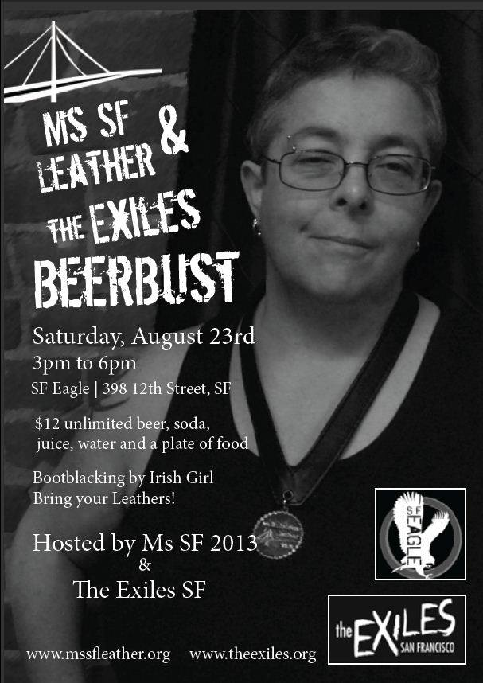**

**The Exiles and Ms. SF Leather Beer Bust Scheduled at the SF Eagle**

Plan Now for Saturday, August 23rd from 3-6 p.m.

Join The Exiles and Ms SF Leather at The Eagle for some summer fun! $12 gets you a bottomless cup for beer, soda and juice, and a plate of food. Did I mention we will have lots of good food and an enormous amount of fun?   
  
This event is open to ALL GENDERS so invite all your friends!   
  
 [Irish Grrl](https://www.facebook.com/irish.grrl) will be bootblacking for us! And we are looking for additional volunteers to help so if you’d like to come and help, we will comp your entrance in trade for some of your time! To volunteer, contact Raven at [ladyravenfyr@aol.com](mailto:ladyravenfyr@aol.com)  
  
And, it starts early so you can still do all of your evening events as well, like the ACLC contest. Come out and support your local leatherwomen!

The link to this event is: <https://www.facebook.com/events/665864516824979/>.

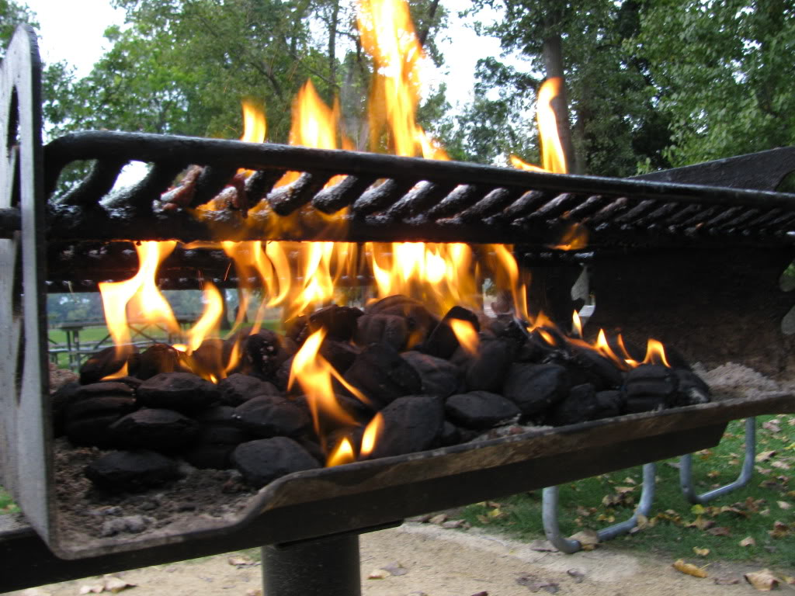It’s a ***Where are The Exiles Going?*** Barbecue

What better way to have conversation centered around the direction of The Exiles than over food? Come join us for a BBQ potluck and discussion on Sunday August 24th from 1-4 p.m.

Bring your best ideas and a side dish to share. Meat, seafood, and meatless options are on us! Be sure to pack in your appetite for fun and conversation. Location revealed with your RSVP to jaxtrble@yahoo.com

**Meeting Minutes** ~

The Exiles business meeting minutes have not been published here in the Fringe for a couple of months due to our inability to vote to approve them at our business meetings. Votes require a quorum of 5 voting members, and unfortunately we have not had that at the last few meetings. This is a symptom of an overall lack of participation by more than a core group of members and officers. **We’re hoping you will consider participating.**

If you want show your support and have a say in how your club is run, *please come to the business meetings!* These are held on the first Sunday of each month from 5-7 p.m., alternating between the East Bay and SF. The next meeting will be on Sunday, September 7 at Alchemy in SF. This is your club… so come join us, and have your say in the direction of the Exiles. I’ll even bring snacks! ☺

The Folsom Street Fair is just around the corner and the Exiles has something special planned for the September program.

Instead of our regular program we are kicking off Folsom Weekend by hosting a Meet & Greet at The Center for Sex and Culture on September 19th from 7-9 p.m. Please note the earlier time, to allow everyone to get to their play party of choice during these Holy Days of Leather!

We will have raffle tickets! We will have hot, live demos throughout the evening! We will have food! This is free to our members, and $5-$20 sliding scale for nonmembers (no one turned away for lack of funds). We will have our coveted pins on hand for sale and lots of leather family supporters. We understand that Folsom weekend calendars fill up fast, so put this on your calendar now; we’d love to have you join us!

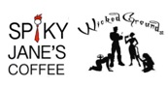  And This Just in… Lets support our local community!

'Wicked Grounds Cafe - Now Even More Wicked!'

The IndieGoGo campaign just kicked off to help take Wicked Grounds to the next level. Wicked Grounds has some big plans for the café, and they’re engaging with the community to help bring in some super-fun things (like a cage table! And more bondage chairs!) as part of their renovation process. They are offering some pretty cool rewards for those who contribute.

They are hoping that our community will be willing to help them share the word through the Exiles newsletter and so we are! . The easy link to use is [http://www.igg.me/at/wickedgrounds](http://www.igg.me/at/wickedgrounds" \t "_blank)  ☺

We hope you’ll take a moment to check it out on Indiegogo and also share it with your community. All the tools are there. Get perks, make a contribution, or simply follow updates. If enough of us get behind it, we can make 'Wicked Grounds Cafe - Now Even More Wicked!' happen!